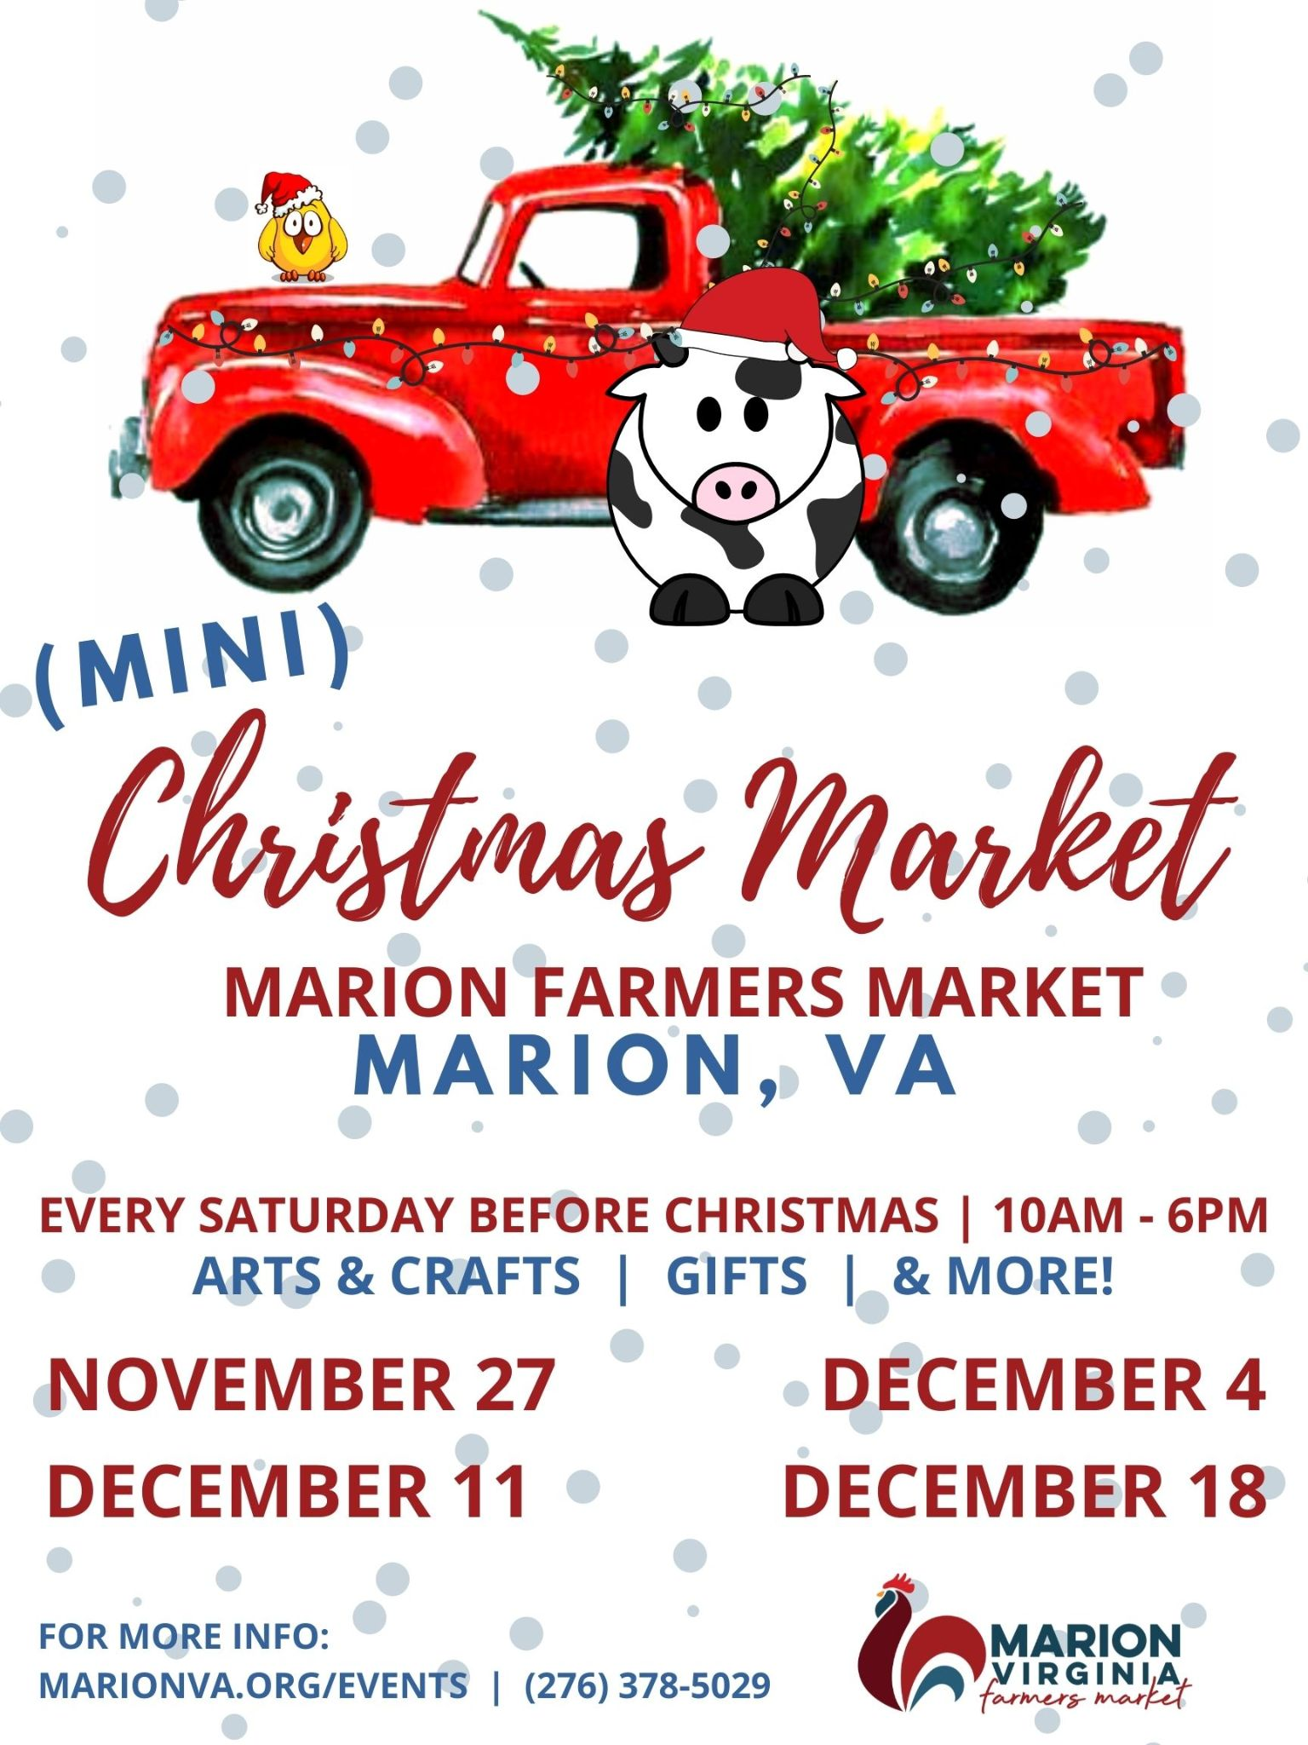2021 | Merry Marion (Mini) Christmas Market
Our (Mini) Christmas Market will be hosted at the Farmers Market only the four Saturdays between Thanksgiving and Christmas.
Each mini-market will host 22 Vendors only. Booths must be tables/displays only. You may bring a tent, but no side walls will be allowed - everything needs to be open air. Tables must remain 6 ft from neighboring vendors.

(Mini) Christmas Market Vendors & Dates
Vendors must sell artisan crafts and goods only. Items must be handmade or locally produced. (No direct sales.) Booths will be outdoors under the market shelter. Booths are roughly 10 ft. by 10 ft. Electricity may be used for lighting only. No heaters, crockpots, cooking devices, etc. allowed. All devices must be pre-approved. We will be providing gas-powered outdoor heaters. All vendors agree to follow the precautions listed above.
Please select your preferred date(s) for attending. All registrations are first come, first served with priority to hand-crafted items. We will notify all vendors via email by November 13 of the date(s) they will be attending.

________ Saturday, November 27 10 a.m. - 6 p.m. $25 per day

________ Saturday, December 4 10 a.m. - 6 p.m. $25 per day

________ Saturday, December 11 10 a.m. - 6 p.m. $25 per day

________ Saturday, December 18 10 a.m. - 6 p.m. $25 per day

Name _____________________________________________________ Email ________________________________
Phone ____________________________________ Address ________________________________________________
City _____________________________________________________________ State ________ Zip _____________
Business/Booth Name _______________________________________________________________________________
Describe Your Product(s) _____________________________________________________________________________
__________________________________________________________________________________________________
Special Requests ____________________________________________________________________________________

Registration Deadline: November 12th at 5 p.m.

Make Checks Payable: The Henderson School

Mail/Return Check & Form: Town of Marion Community & Economic Development
P.O. Box 1005 | Marion, VA 24354
You may use Dropbox at Town Hall

More Information: Contact Cyndi McCloskey at 276.378.5029 or cmccloskey@marionva.org

Please Follow all current CDC and VDH guidelines
Thank You!

