Below are pictures of how your brush piles should be placed for pickup.
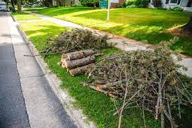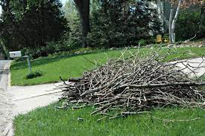

Below are pictures of how your brush piles SHOULD NOT be placed for pickup.
