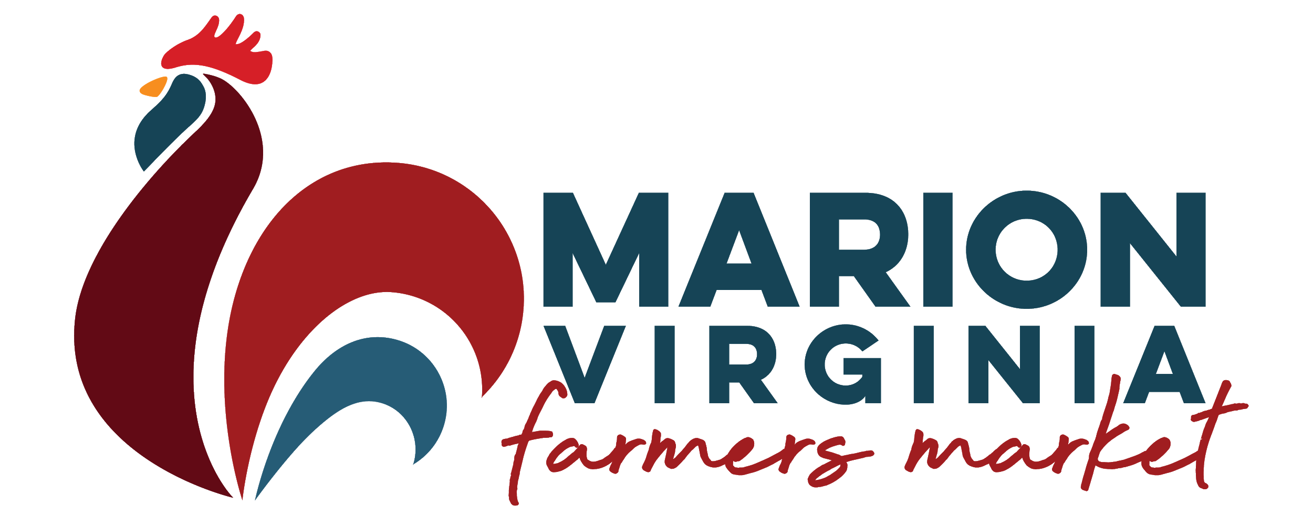
MARION FARMERS MARKET | VENDOR APPLICATION
May - October | Every Saturday | 8 a.m. - Noon
At the Corner of Cherry & Chestnut Street in Marion, VA.

Space Rental
All spots are approximately 10 ft. x 10 ft. and can accommodate a vehicle. Prices listed below are valid for the Regular Market Season and Thanksgiving Market No refunds. There are no fees for Winter Markets.

_____ Pay by The Day $5
Pay for your spot each Saturday. Simply contact the Market Manager to reserve your space for the upcoming market.

_____ Season Pass $150 (Receive a personalized sign install)
_____ Season Pass $130 (NO personalized sign install)
Reserve your favorite spot for the entire Regular Season. (Must attend for a ten-week minimum.)
2022 | Vendor Information
Please print all information, except for your signature. Please include space rental fees with the application.
Vendor/Business Name ______________________________________________________________________
Description of Products for Sale ________________________________________________________________
__________________________________________________________________________________________
__________________________________________________________________________________________
Space # Requested ___________

Contact Person _____________________________________________________________________________
Address ___________________________________________________________________________________

City _______________________________________________ State ______________ Zip Code __________
Cell Phone ___________________________________ Alternate Phone _______________________________
E-mail ____________________________________________________________________________________
Facebook/Instagram ________________________________________________________________________
Emergency Contact _________________________________________________________________________
Cell Phone ___________________________________ Alternate Phone _______________________________

I (we) have received and will comply with all the Marion Farmers Market rules and regulations.
Signature _________________________________________________________ Date __________________
Make Checks Payable: Marion Farmers Market

Mail/Return Check & Form: Town of Marion Community & Economic Development
P.O. Box 1005 | Marion, VA 243545
More Information: Contact Leslie Vanover, Market Manager
276.620.1300 or lvanover@marionva.org

